
Home Learning
This week we are learning…
Physical Development

Formation of letters
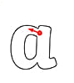
Personal, Social and Emotional
Our school value this term is Care.
How are we feeling? What can you do if you feel sad or angry?

Understanding the World
Easter story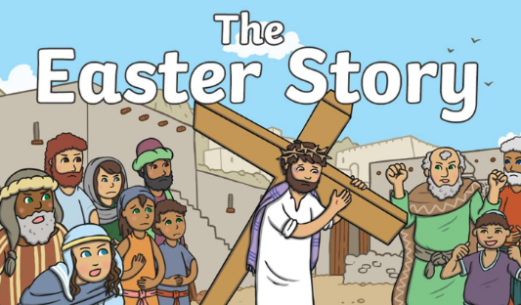

Maths
Take-away with 10

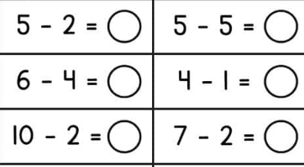

Reception Class
Week Beginning:
18th March 2024
Literacy, Communication and Language
Performing Colour by Christina Rossetti – Poem
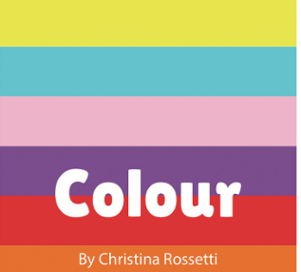

Expressive Arts and Design
Mixing colours

